“Customer Segmentation & Churn Pattern Analytics in European Banking”

Introduction
When clients quit using a business's services or terminate their accounts, it's referred to as customer churn. Churn in the banking industry happens when clients switch banks or end their financial ties. Because it shows customer discontent, pressure from competitors, or low involvement with banking services, it is an important measure.
Because it is much more expensive to acquire new clients than to keep existing ones, churn is particularly relevant in the banking industry. Increased marketing and acquisition expenses, decreased client lifetime value, and direct revenue loss are all consequences of a high turnover rate. In order to sustain long-term stability and profitability, banks must constantly analyze churn behavior.
Furthermore, client churn is not always random; it is frequently impacted by certain elements like subpar customer service, low engagement, expensive fees, or superior offerings from rival businesses. Banks can determine which client segments are most likely to depart and take proactive steps to keep them by examining these trends.
This project's goal is to discover the main causes of customer attrition by analyzing customer turnover patterns using a dataset from European banks. In order to better analyze attrition behavior, the initiative intends to divide consumers based on attributes including age, geography, balance, and activity level.
The study aims to identify high-risk clientele through this analysis and offer useful information that can assist banks in creating focused retention plans. Businesses can take preventative measures, lower churn rates, and increase overall customer satisfaction and loyalty by identifying hazardous consumers early.

Abstract
In the banking industry, customer churn is a significant problem since losing clients has a direct effect on growth and income. The goal of this research is to identify high-risk client segments by analyzing and comprehending churn trends in a dataset from a European bank. About 10,000 customer records with attributes like age, balance, location, tenure, and product consumption make up the dataset.
Python was used for the analysis, utilizing packages like Plotly for interactive visualizations and Pandas and NumPy for data processing. Streamlit was used to create an intuitive dashboard that allowed for real-time insights and dynamic filtering.
Key findings indicate that high-value consumers, certain geographic areas, and inactive customers have increased churn. The experiment emphasizes the significance of focused retention strategies based on customer segmentation by highlighting the uneven distribution of turnover.
The findings show that customer churn is not evenly distributed and is impacted by a number of variables, including high balance, inactivity, and geographical variations. The results highlight the significance of data-driven decision-making and focused retention tactics in the banking industry.

INDEX
- Project Overview ----------------------------------------------------------------------- 1
1.1 Project title 1
1.2 objective 1
1.3 Stakeholder 1
2. Data Description ----------------------------------------------------------------------- 2
2.1 Dataset columns 2
2.2 Data Preparation 2
3. Methodology ------------------------------------------------------------------------ 3 & 4
3.1 Tools and Technologies 3
3.2 Analytical Approach 4
4. Architecture ------------------------------------------------------------------------- 5 & 7
4.1 Dashboard Module 5
4.2 Color & Design 5
4.3 KPIs creation 6
4.4 Filters 7
5. Visualization \ Dashboard ----------------------------------------------------------- 8 & 10
5.1 Visualization 8
5.2 Insights 10
6. Future Work -------------------------------------------------------------------------- 11
6.1 Future Work 11
7. Conclusion ------------------------------------------------------------------------ 12 & 13
7.1 Conclusion 12
7.2 Reference 13

- Project overview

1.1 Project title
“Customer Segmentation & Churn Pattern Analytics in European Banking”

1.2 objective
• To examine consumer data and pinpoint the main causes of bank churn in Europe.
• To identify high-risk groups by segmenting clients based on characteristics like age, balance, and location.
• To compute and track critical KPIs including engagement decline, high-value churn, and churn rate.
• To create an interactive dashboard for real-time analytics and dynamic filtering using Streamlit.
• To offer useful business insights that enhance retention tactics and lower customer attrition.

1.3 stakeholder
From a stakeholder viewpoint, the primary goal of this project is to give decision-makers a clear picture of customer turnover patterns so they can quickly determine which customer categories are most likely to leave. The dashboard assists stakeholders in concentrating on the most susceptible groups and implementing focused measures to lower churn by examining variables like age, balance, and geography.
Highlighting high-value clients who are in danger is another crucial goal because losing these clients can have a direct effect on revenue. Stakeholders can swiftly evaluate business performance and pinpoint crucial areas that require improvement thanks to the dashboard's straightforward and interactive presentation of important performance metrics including churn rate, high-value churn, and engagement decline.
Additionally, by providing an intuitive and engaging interface, the initiative facilitates data-driven decision-making. Without needing technical expertise, stakeholders can apply filters, investigate various segments, and obtain real-time insights. In the end, this strengthens overall corporate performance, increases customer satisfaction, and improves client retention tactics.

2. Dataset Description

2.1 Dataset columns
About 10,000 client records from a European bank make up the dataset used in this study. It has a number of characteristics that define the financial situation, involvement levels, and demographics of its customers. The dataset is appropriate for exploratory data analysis and is well-structured. There are 14 columns in dataset but the important columns are below:
Age, Balance, Geography, Tenure, number of products as (NumOfProducts), and activity status are some of the dataset's important characteristics. These characteristics offer information on consumer behavior and financial involvement. To make analysis easier, categorical variables were also divided into parts like Age_Group and Balance_Group.
"Exited" the goal variable, shows whether or not a customer has churned. Churned customers are represented by a value of 1, and retained customers by a value of 0. Churn patterns across several segments can be analyzed thanks to this binary classification.
In order to manage missing values, produce meaningful segments, and encode categorical variables, data preprocessing was carried out. Geographical segmentation was done using dummy variables, and the dashboard's interpretability was enhanced by the creation of derived columns.

2.2 Data Preparation
The European bank customer dataset was loaded into Python using Pandas to start the data preparation process. The structure of the dataset, including the number of rows, columns, and data types, was thoroughly investigated. Important factors like customer demographics, account information, and the target variable Exited which shows whether a customer was retained or churned were found during preliminary investigation.
Next, duplicate records, discrepancies, and missing values were examined in the dataset. Duplicate entries were eliminated to prevent biased analysis, and any missing or null values were correctly handled to preserve data integrity. Because poor data quality can result in inaccurate insights and untrustworthy outcomes, it is crucial to ensure clean and consistent data.
Data types were also checked and adjusted if needed. While category variables were appropriately organized for analysis, numerical columns like age and balance were made sure to be in the right format. This stage guarantees that the dataset can be used with tools for analysis and visualization. In order to prepare the dataset for additional analysis, basic formatting and organization were carried out.

3. Methodology
3.1Tools and technologies
Python
The entire project, from data processing to dashboard construction, is built using Python as the primary programming language. It is perfect for activities involving data analysis and visualization due to its simplicity and vast environment.
Visual Studio Code (VS Code)
The main development environment for authoring, debugging, and organizing project code is Visual Studio Code. It makes coding effective and structured with its robust extensions, syntax highlighting, and integrated terminal support.
Pandas, NumPy
While NumPy facilitates effective numerical computations, Pandas is utilized for data management, cleaning, and filtering. When combined, they allow for the quick processing of complicated transformations and big datasets.
Plotly
Plotly is used to make visually beautiful and interactive charts that improve the dashboard's user experience Instead of using static visualizations libraries i.e. Matplotlib and seaborn.
Streamlit
The interactive web dashboard is constructed with little code using Streamlit. It makes the application dynamic and user-friendly by facilitating the simple integration of filters, KPIs, and visualizations.

3.2 Analytical approach
This project's methodology starts with data cleaning to guarantee consistency and accuracy in analysis. Duplicate records, erroneous data types, and missing values were examined in the dataset. The quality of the data was maintained by carefully handling any discrepancies. This is an important step since inadequate or erroneous data might influence the reliability of the results and produce misleading insights.
In order to extract more significant variables from the available data, feature engineering was then used. Age_Group and Balance_Group are two examples of new category attributes that were developed to divide consumers into comprehensible groups. For instance, account balances were classified into low, medium, and high groups, while age was divided into ranges (young, middle-aged, and senior). These changes made it simpler to examine customer segment-specific churn behavior.
Encoding techniques were applied to handle categorical variables. Using one-hot encoding, the Geography column was converted into dummy variables (Geography_Germany, Geography_Spain, etc.). As a result, categorical data in a numerical format could be processed by the model and analyzed. To improve dashboard viewing and filtering, a derived Geography label was also developed from these dummy variables.
The Streamlit dashboard has filtering algorithms to facilitate dynamic data analysis. Filters based on geography, balance group, and age group can be applied by users. All key performance indicators (KPIs) and visualizations are then updated in real time using the filtered dataset, enabling users to interactively examine churn patterns and concentrate on particular client segments.
Lastly, the filtered data was used to compute important indicators like the overall churn rate, high-value churn ratio, regional risk index, and engagement drop indicator. These measurements aid in the identification of patterns and high-risk groups, as do visualizations made with Plotly. Preprocessing, feature engineering, encoding, and dynamic filtering work together to provide a thorough and adaptable analytical method.

4. Architecture

4.1 Dashboard Design
Streamlit, a Python-based framework that facilitates the development of interactive and user-friendly online applications, was used to create the dashboard for this project. Because of its ease of use, adaptability, and smooth integration with data analysis tools like Pandas and Plotly, Streamlit was selected. To improve both visual appeal and usability, the dashboard is built with an organized layout and personalized styling.
The dashboard's use of interactive filters is one of its main characteristics. Users can examine churn tendencies across various client segments by filtering the dataset according to Age Group, Balance Group, and Geography. These filters give the dashboard a great deal of flexibility and let users do targeted research without changing the underlying data.
Additionally, the dashboard has dynamic Key Performance Indicators (KPIs) that change on their own according to the filters that have been chosen. Real-time calculations are made for metrics including Segment Churn, Geographic Risk Index, High-Value Churn, Overall Churn Rate, and Engagement Drop Indicator. In order to help consumers better comprehend the metrics, an expansion section is also included that offers concise explanations of each KPI. This guarantees that users always see precise and relevant information.
Users can export filtered data for additional analysis thanks to additional features like a dataset download button. Key features and project objectives are included along with dataset information in another expansion section. The dashboard is now a comprehensive decision-support tool thanks to these improvements, which also make it more engaging, educational, and interactive.

4.2 color & design
The dashboard's deep purple background (#61155c) and contemporary dark theme, which draws inspiration from high-end banking interfaces, create a polished and aesthetically pleasing setting. In order to distinguish navigation from the main content, the sidebar is stylized with a somewhat darker color (#4e124a). The dashboard has an elegant and analytical look thanks to the strategic use of accent colors like gold (#e1bd78), light blue (#87d3e1), and yellow-green (#CFD75D) to draw attention to crucial components like titles, filters, and critical findings.
To improve usability and aesthetics, interactive elements like buttons and multiselect filters have rounded edges and soft transparent backgrounds. While KPI measures are highlighted with bright green (#4DE49D) for values and contrasting colors for labels to ensure that key performance indicators stand out clearly, hover effects on sidebar buttons provide interaction.
With charts utilizing the same dark background as the main interface and neat formatting by eliminating superfluous gridlines, all visualizations adhere to the same design language. Bar charts, pie charts, and histograms employ gold and complementary tones to preserve visual coherence while clearly differentiating between categories like kept and churned consumers. The charts' analytical value and clarity are further improved with percentage labels and hover interactions.
The dashboard also has sophisticated user interface features as a dedicated insights panel in the sidebar, themed expanders for dataset information and KPI explanations, and an animated scrolling title (marquee). These elements enhance the dashboard's user experience while also making it more engaging and educational.

4.3 KPIs creation
Key Performance Indicators (KPIs) were created to quantify and analyze customer attrition from many business angles. The Churn Rate, which shows the proportion of clients who have left the bank, is the main KPI. This measure gives a broad picture of customer retention performance and aids in determining the scope of the issue.
Customers with large account balances are the target audience for the High-Value Churn KPI. These clients' high revenue contributions suggest that the bank may be at jeopardy financially. Monitoring this KPI makes it easier to determine whether premium clients are departing more frequently.
The areas with the highest churn rates were determined using the Geographic Risk Index. This KPI demonstrates location-based risk patterns by comparing churn across nations such as France, Germany, and Spain. This enables the bank to target high-risk areas with retention initiatives.
The Engagement Drop Indicator calculates the difference in customer turnover between active and inactive clients. Understanding how customer interaction affects retention is made easier by this KPI. The significance of engagement techniques is shown by a larger gap, which suggests that inactive users are more likely to churn.
Furthermore, the Segment Churn KPI was developed to examine churn within particular customer segments, including age groupings. This enables more in-depth understanding of the demographic groups that are most likely to depart. It facilitates focused decision-making and aids in creating customized retention plans.

4.4 Filters
The dashboard has interactive sidebar filters that let users examine customer attrition by segment, including geography, age group, and balance group. Multiselect options are used in the implementation of these filters, allowing users to choose one or more categories at once. This adaptability makes the analysis more targeted and significant from a commercial standpoint by allowing for the investigation of how churn behavior differs among various client segments.
Every time a user applies a filter, the dataset is instantaneously updated and all KPIs and visualizations reflect the chosen conditions because the filtering logic is dynamic. Users can do fast comparisons and delve down into particular segments without having to reload the dashboard thanks to this real-time interaction. Additionally, encoded variables are used to build a user-friendly Geography column, guaranteeing that location-based filtering is clear and consistent throughout the dashboard.
A Reset Filters option that removes all selected filters and returns the dashboard to its default view is included to improve usability. This feature makes navigating easier and makes it simple for users to resume their analysis. All things considered, the filtering mechanism enhances interaction, facilitates more in-depth data exploration, and aids users in obtaining more precise and useful dashboard insights.

5. Visualization/Dashboard
5.1 visualization
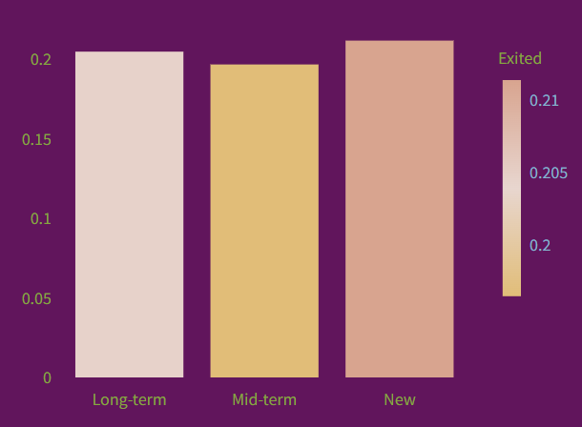
This bar chart shows the churn rate across different customer tenure groups: Long-term, Mid-term, and New customers.The highest churn rate (around 0.21) is seen in the new customers sector, suggesting that newly acquired customers are more likely to depart the bank. Long-term clients have comparatively superior retention, with a significantly lower churn rate (around 0.20). This suggests that, in comparison to new users, clients who stay longer tend to develop loyalty and are less likely to leave.Overall, the graphic shows that early-stage customer retention is the most difficulty, and banks should concentrate more on enhancing the experience of new customers. Of the three groups, mid-term clients had the lowest turnover rate (around 0.195).
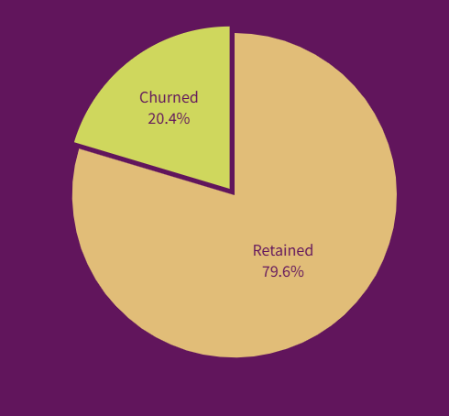
79.6% of customers are kept and 20.4% have churned, according to the pie chart that shows the total distribution of customer turnover. This demonstrates that the bank is able to keep a sizable portion of its clientele, which suggests that most users receive satisfactory service and typically stable customer relationships.
The 20.4% churn rate, however, is still noteworthy and amounts to a sizable loss of potential income. This emphasizes the significance of identifying high-risk sectors and putting focused retention initiatives into place, particularly for customers who are more likely to depart.

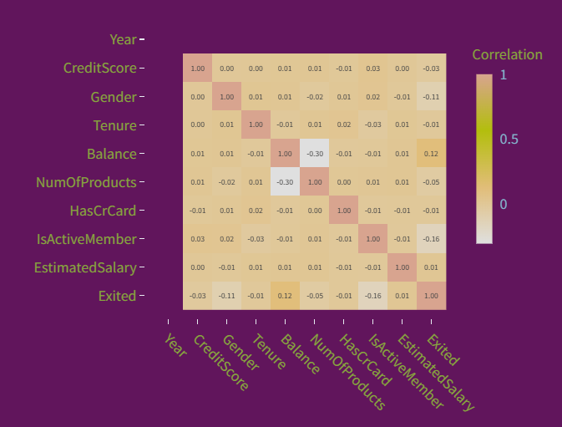
The heatmap illustrates the relationship between various customer attributes and churn (Exited). The majority of factors show relatively modest associations with churn, suggesting that no single factor significantly influences customer attrition. A few characteristics, however, stand out a little. IsActiveMember has a negative correlation (~ -0.16), indicating that active customers are less likely to churn, while Balance has a modest positive correlation (~ 0.12), indicating that consumers with higher balances may be somewhat more likely to leave.
Furthermore, factors like Tenure, HasCrCard, and EstimatedSalary have almost no associations with churn, and CreditScore and Gender have very little effect. Overall, the figure indicates that a variety of factors rather than a single dominant characteristic drive churn, underscoring the necessity of segmentation and more thorough study rather than depending solely on one feature.
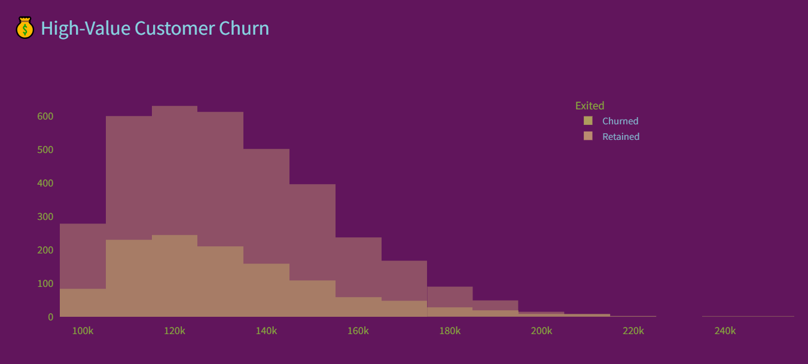

The distribution of balances among high-value clients is displayed by the histogram, which contrasts those who have been retained with those who have left. The majority of consumers are clustered in the balance range of $100,000 to $150,000, where both churned and retained customers are present, although the number of maintained customers is marginally higher. This suggests that a sizable percentage of high-value clients are still devoted to the bank.
The number of consumers declines and churn becomes less common but still occurs as the balance rises above $150,000. This implies that having a larger balance does not ensure retention, underscoring the necessity of tailored interaction tactics even for high-end clients.

5.2 insights
According to the data, Germany has the highest churn risk of any region, suggesting that geography has a significant influence on customer retention. This implies that consumers in this area might be experiencing service deficiencies, pressure from competitors, or discontent, making it a top target for focused retention tactics.
Since inactive consumers exhibit much greater churn rates than active users, client engagement is crucial. This emphasizes the significance of ongoing engagement through tailored offers, notifications, and relationship management since evidence shows that a lack of connection with financial services directly raises the likelihood of clients departing.
Another important finding is that the bank faces a significant revenue risk due to the high-balance (premium) customers' noteworthy rate of attrition. Because these clients add greater value, their departure may have a disproportionately large financial impact, suggesting that high-value segments require particular retention initiatives.
Furthermore, not all populations experience churn equally; some age groups exhibit stronger churn tendencies than others. Overall, the results show that demographics, customer value, engagement level, and region all have an impact on attrition.
6. Future work

6.1 Future work
The analytical and commercial value of this study can be greatly increased by future advancements. A significant development would be the incorporation of a machine learning model to forecast customer attrition. A predictive model (such Logistic Regression, Random Forest, or XGBoost) can identify customers who are likely to churn in the future rather than only examining historical trends, allowing for proactive retention measures.
Utilizing real-time or nearly real-time data integration is another significant improvement. The dashboard now operates on a static dataset, but decision-makers may track churn behavior dynamically by connecting it to real financial systems or streaming data pipelines. This would increase the dashboard's actionability and relevance for regular business operations.
Enhancing personalization tactics can also increase client retention. The bank may create offers, recommendations, and engagement programs that are specifically suited to each customer's needs by utilizing segmentation insights, transaction history, and customer behavior. By doing this, the system would transition from descriptive analytics to a more intelligent and customer-focused decision-support tool.

7. Conclusion

7.1 Conclusion
The goal of this study was to identify the major variables affecting customer attrition by examining customer churn trends in a dataset from European banks. Churn was found to be concentrated among particular segments rather than being randomly distributed through in-depth data analysis and interactive graphics. Churn rates were greater among consumers from specific regions, especially Germany, and the likelihood of inactive customers leaving the bank was much higher.
Furthermore, despite their value, high-balance clients showed significant churn behavior, suggesting possible gaps in premium customer engagement. Age group and tenure variations further demonstrated that consumer behavior varies by segment and necessitates focused investigation.
The project's insights are quite useful for making business decisions. Banks may create more successful retention tactics, such tailored offers, better customer service, and proactive engagement programs, by identifying high-risk segments and comprehending the fundamental causes of churn.
Accessibility is improved by using an interactive Streamlit dashboard, which enables stakeholders to dynamically explore data and make timely, well-informed decisions.
All things considered, this initiative shows how crucial data-driven strategies are for lowering customer attrition, raising customer satisfaction, and eventually boosting the company's long-term profitability.

7.2 Reference

• The main source of data for this project's analysis was a public dataset on European bank customer attrition, which was obtained via the site. It offered comprehensive customer data, including tenure, geography, age, balance, and churn status.

• Using online resources like Google and documentation websites, references and educational materials were investigated to have a better understanding of project needs.

• Python tools like Pandas and NumPy for data processing, Plotly and Matplotlib for interactive and insightful visualizations, and Streamlit for dashboard construction were all made easier to understand and use with the aid of online resources and tutorials.

• To improve comprehension of fundamental ideas, academic study materials and assignments from the data science degree were also consulted.

• By using these references, the project was guaranteed to adhere to precise processes, employ suitable analytical approaches, and provide significant business insights via an interactive and well-structured dashboard.

